Part A: Classification Problem

1. The feedforward neural network (FFN) is constructed with a learning rate of 𝛼 = 0.01, batch size of 32, hidden layer neuron number of 10, and weight decay parameter of 𝛽 = 10−6:

a) The accuracies on both training and testing data against epoch are shown in the Figure 1 below:

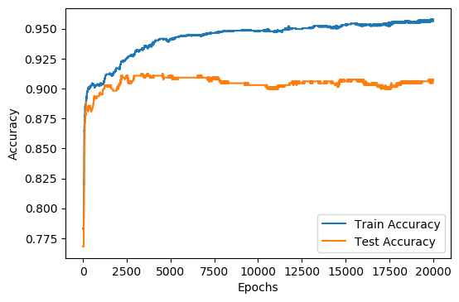

Figure 1

b) The approximate number of epochs where the test error converges is around 4000 epochs. After 4000 epochs, the test accuracy stops increasing and reaches a steady state.

2. The